Phase 5

Lesson 3

**Detach an EBS Volume**

Steps:

1. Selecting the EBS volume you want to detach

2. Detaching the volume

Step 1:

Selecting the EBS volume you want to detach

* Choose the bucket

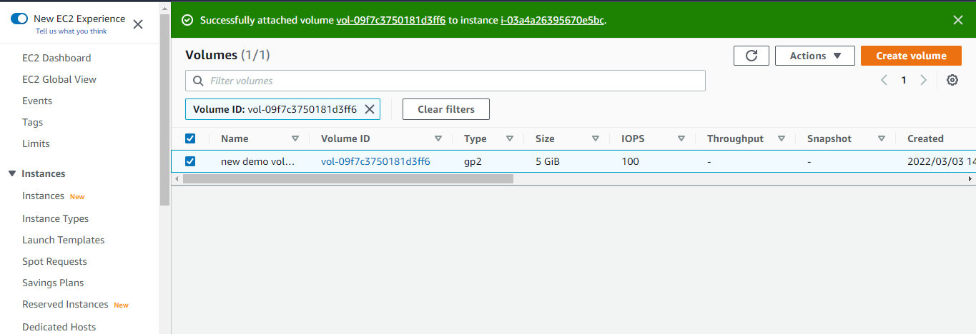

* Select *Detach Volume* option

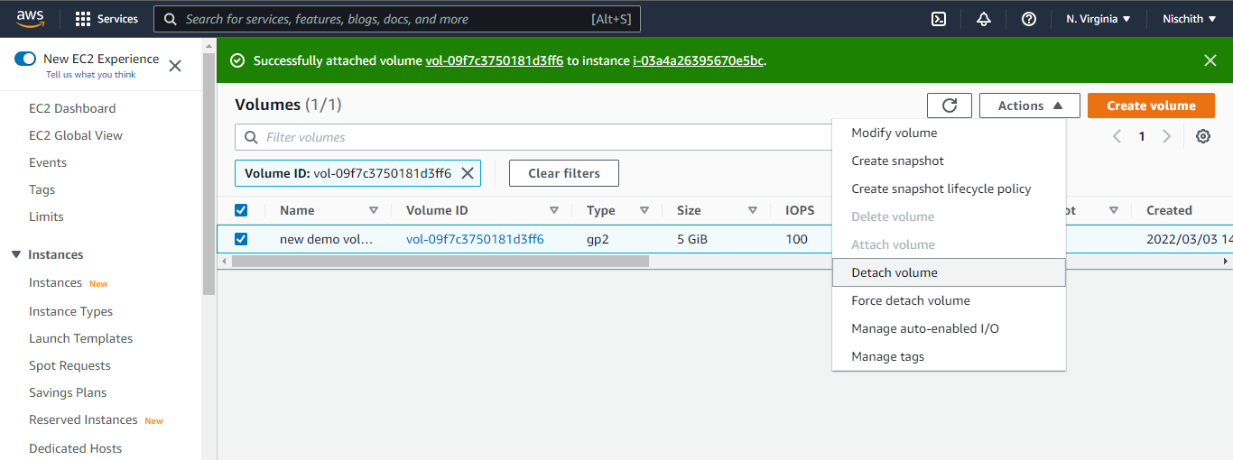

**Step 2:** Detaching the volume

Select *Yes* once the confirmation pop-up appears

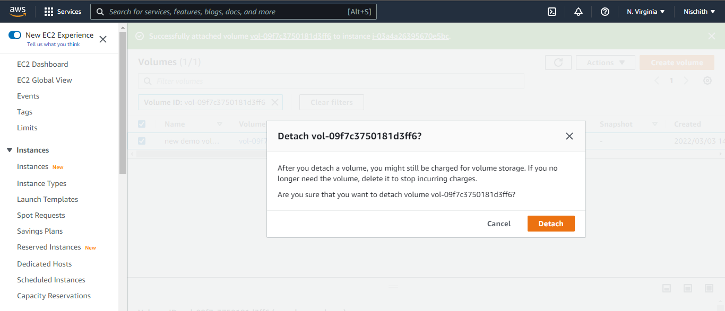

* Once detached, the volume will be labeled as *Available*

